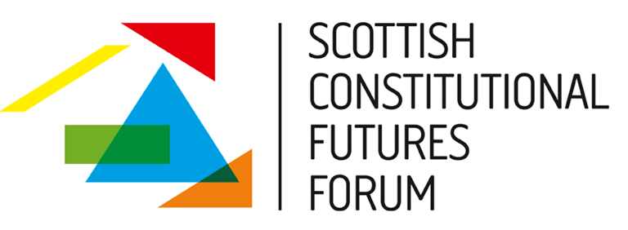

Human Rights and Scotland’s Constitutional Future
Monday 18th March 2013

Where we are now? Human rights and the Independence Debate.
10.15-10.30 - Coffee and Welcome
Session One: 10. 30-11. 45: Chair, Elaine Webster, University of Strathclyde
Human rights protection in Scotland: The current framework, recent developments and issues, Dr. Elisenda Casanas-Adam, Edinburgh Law School
International Human Rights Law: Bringing Rights Home to Scotland whatever the future, Alan Miller, Scottish Human Rights Commission
Coffee Break 11.45-12.00
Session Two: 12.00-1.15: Chair, Sarah Craig, University of Glasgow
The Changing Face of Human Rights in the UK: Bills of Rights, the Council of Europe and the EU, Dr Colm O’Cinneide
Rights and the Development of Constitutional Settlements: Lessons from Northern Ireland, Professor Chris McCrudden, Queen’s University of Belfast
1.15-2.15 Lunch
Session Three 2.15-3.45: Chair, Professor Tom Mullen, University of Glasgow
Scottish Constitutional Futures: An evaluation of the rights implications of different constitutional options and processes
Professor Christine Bell, University of Edinburgh
Round Table Response
- Tam Baillie, Scotland’s Commissioner for Children and Young People
- Carole Ewart, Human Rights Consortium for Scotland
- Dr Ima Jackson, The Glasgow Refugee, Asylum and Migration Network
- Tanveer Parnez, Black and Ethnic Minority Infrastructure in Scotland

